dd. 03-08-2023

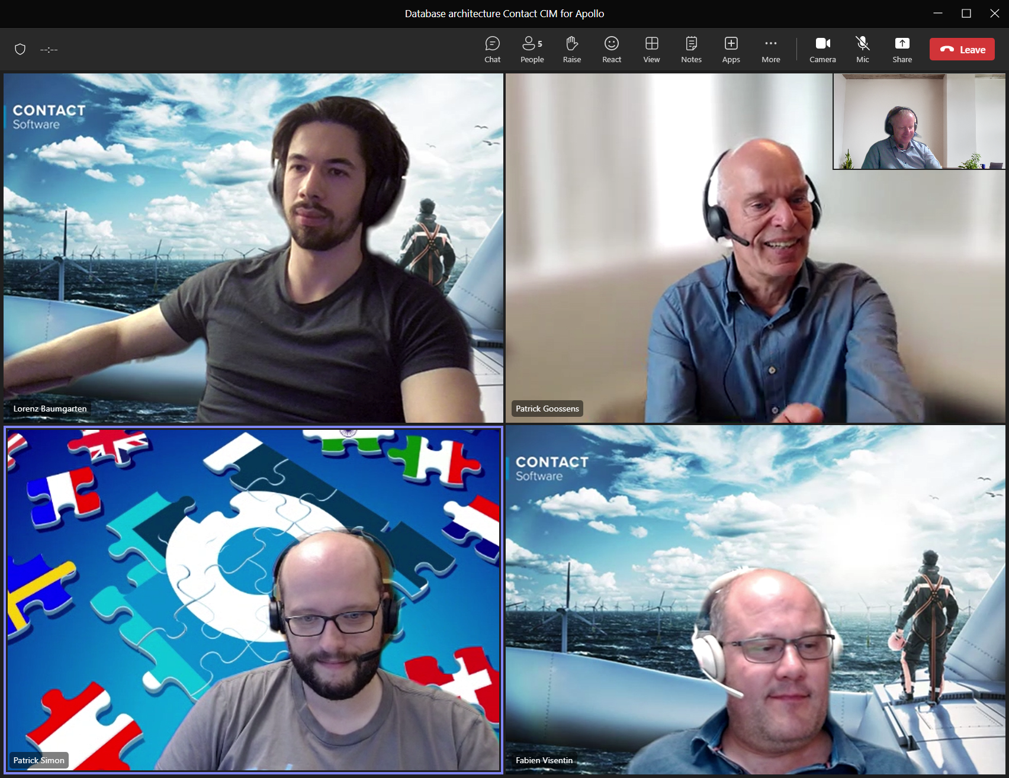

More understanding of the datamodel, specification-part, and planning to use for Laboratory-management. Which data needs to be transferrred.

Patrick: let it stick on the level of property, property-group and sections. And later we can

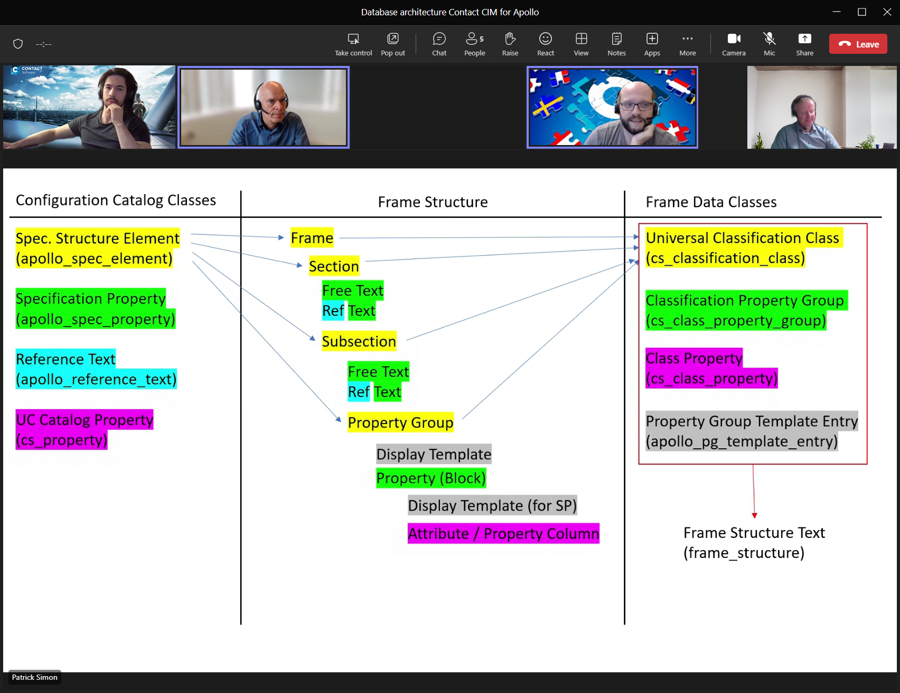

Frame-structure koppel je aan Config-catalog-element.

Contact-property-group-class <> property-group-

Class-property = The values for a class-property.

When we go from

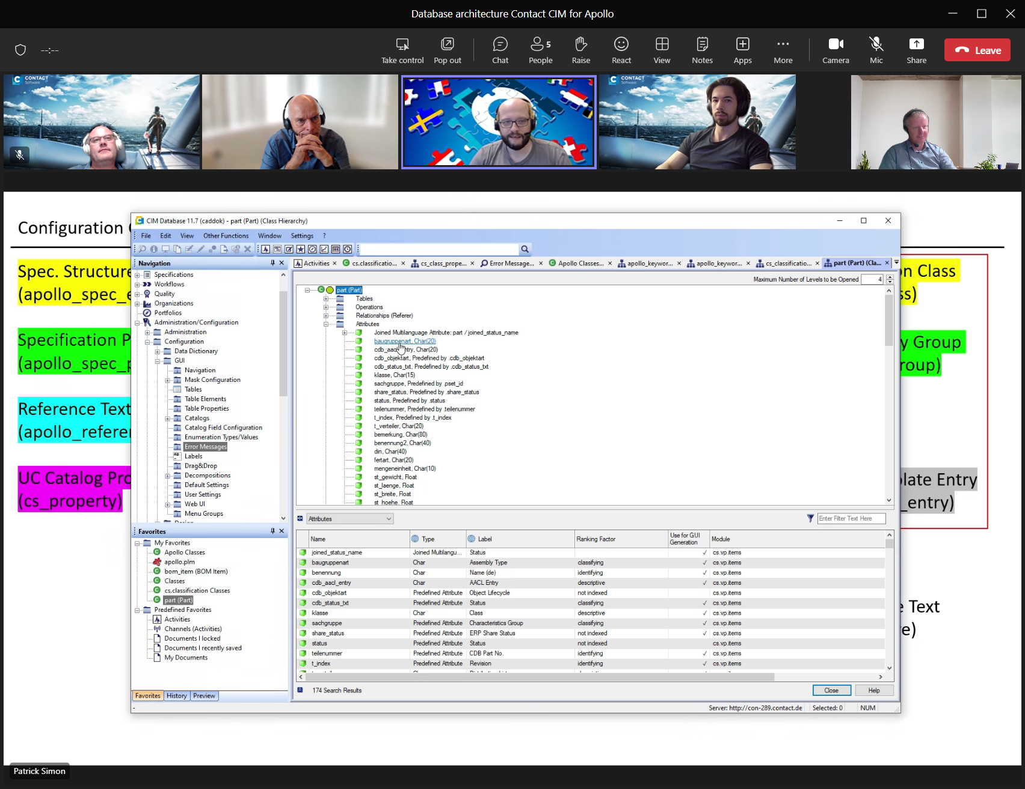

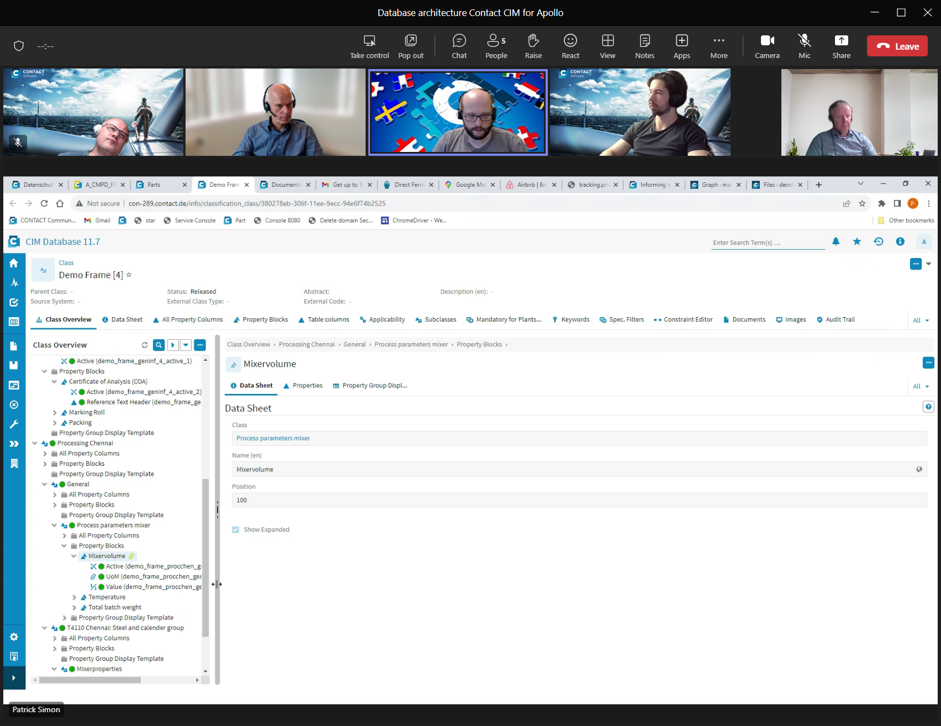

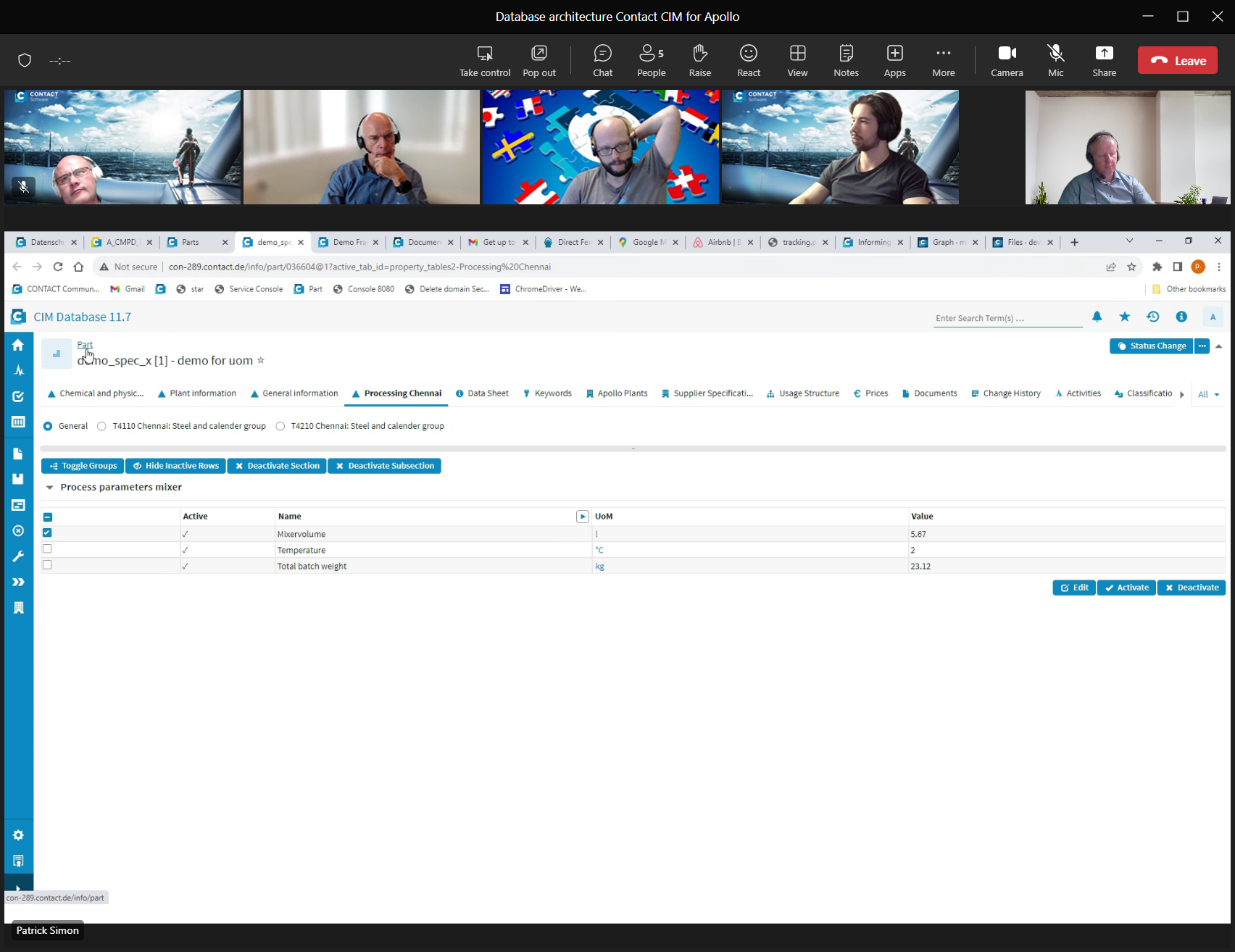

Us-classification is updated,

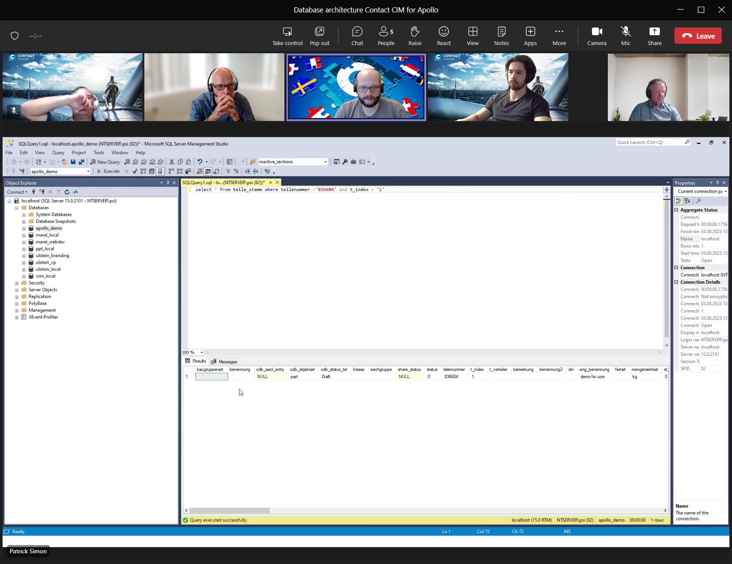

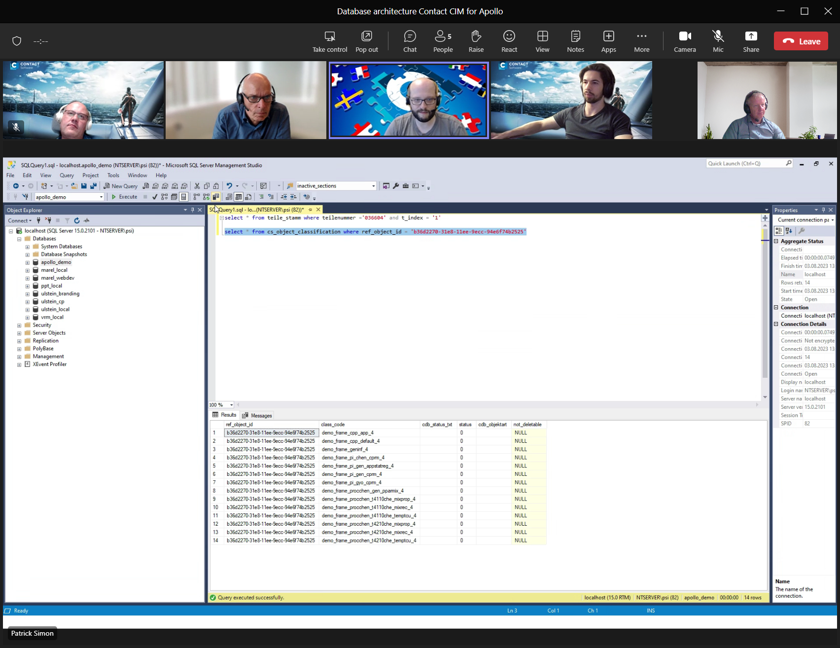

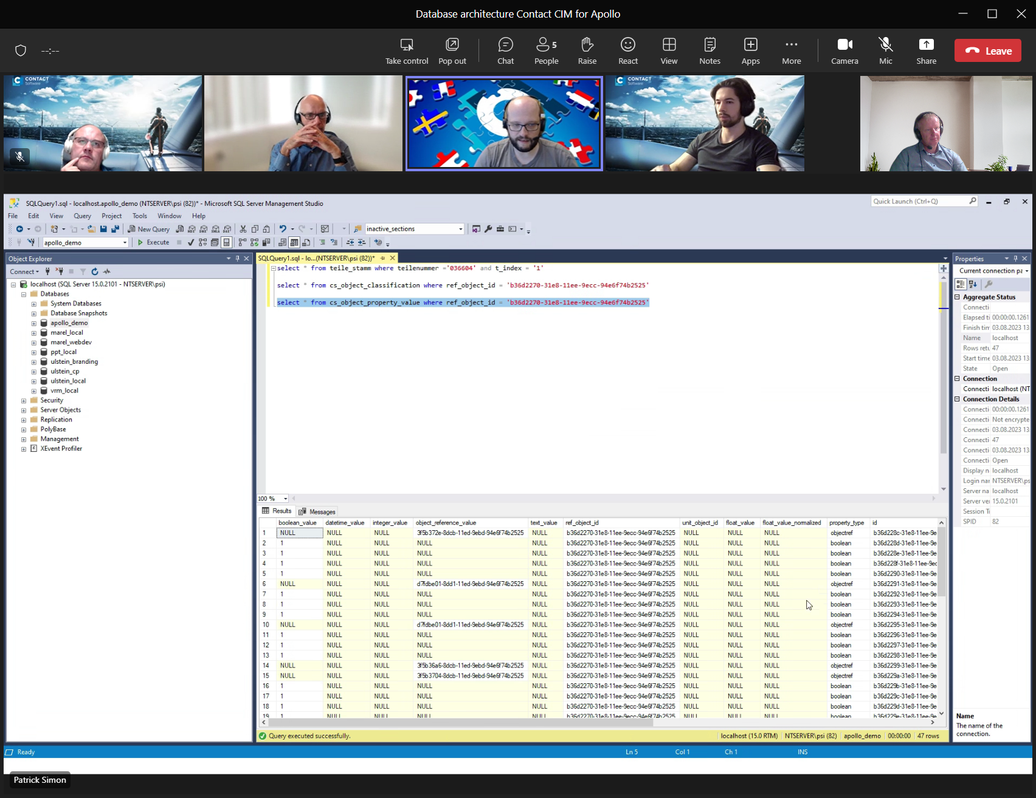

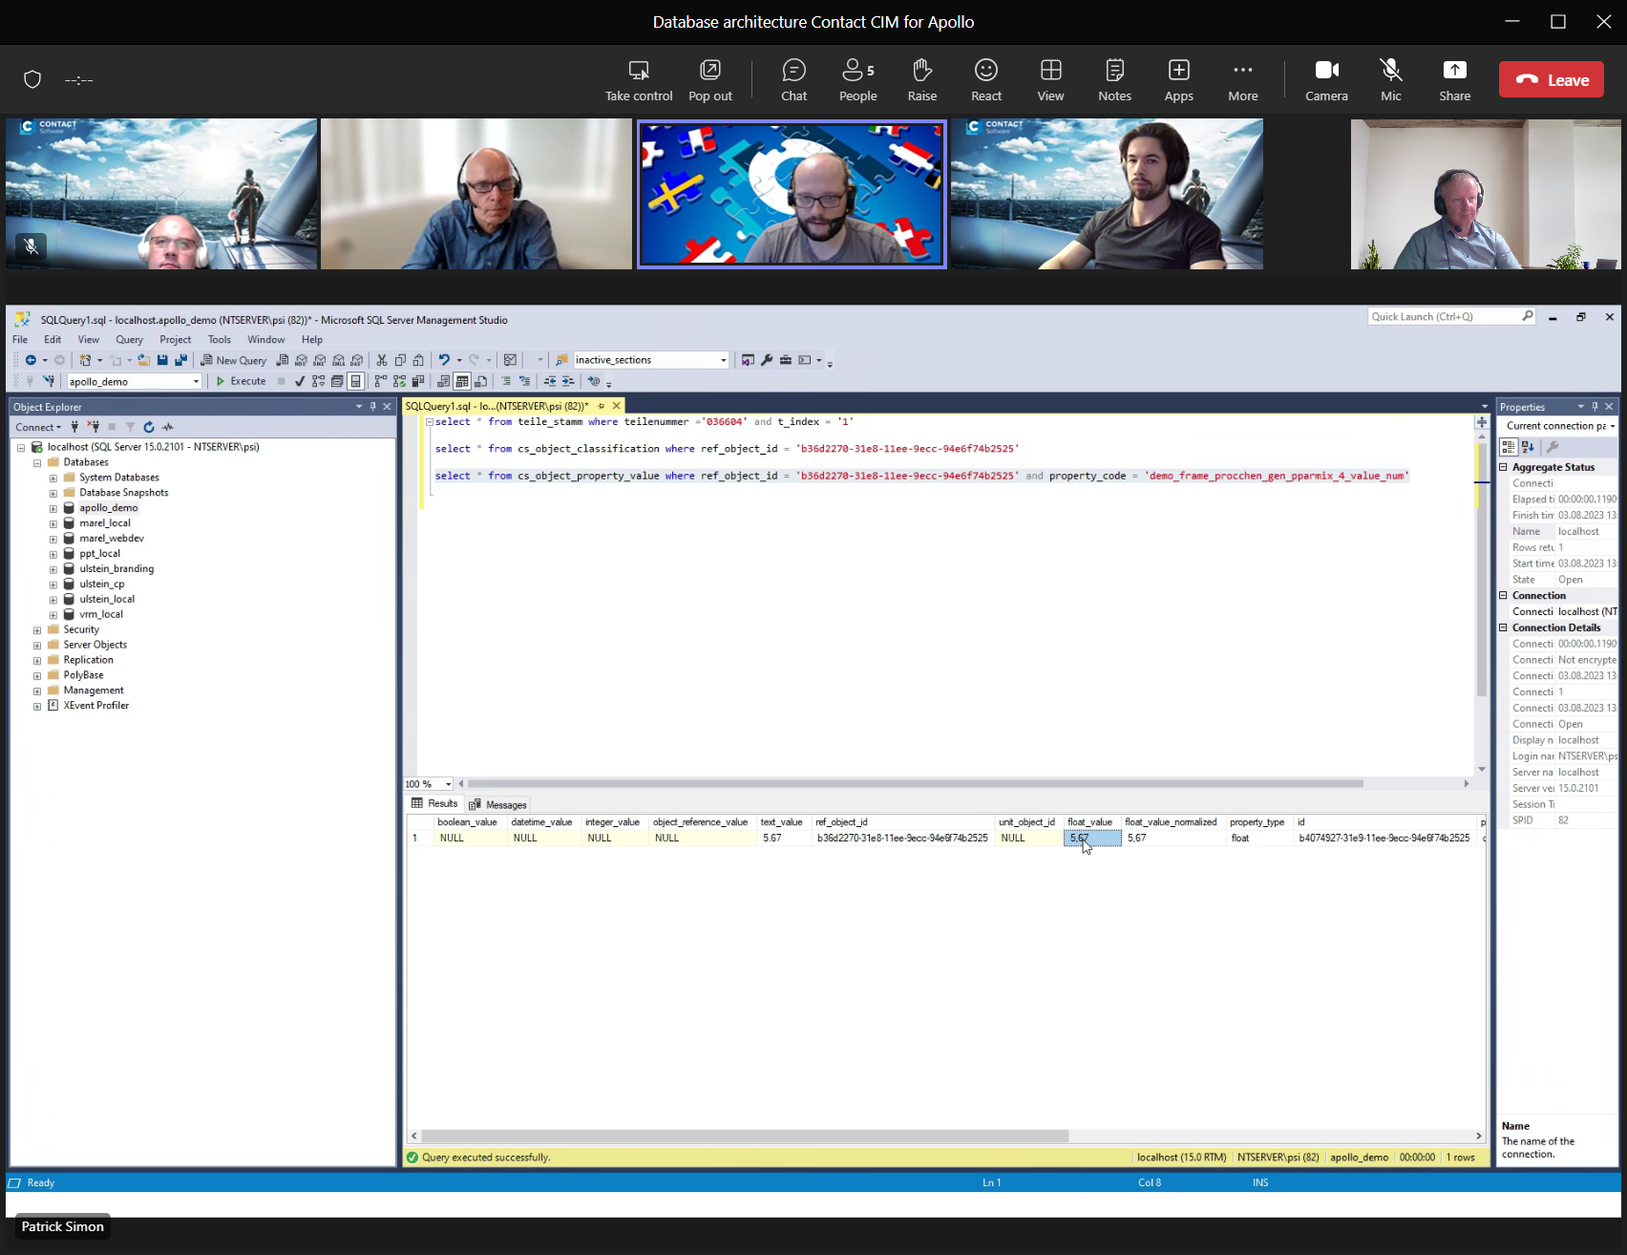

Property-code = frame-property

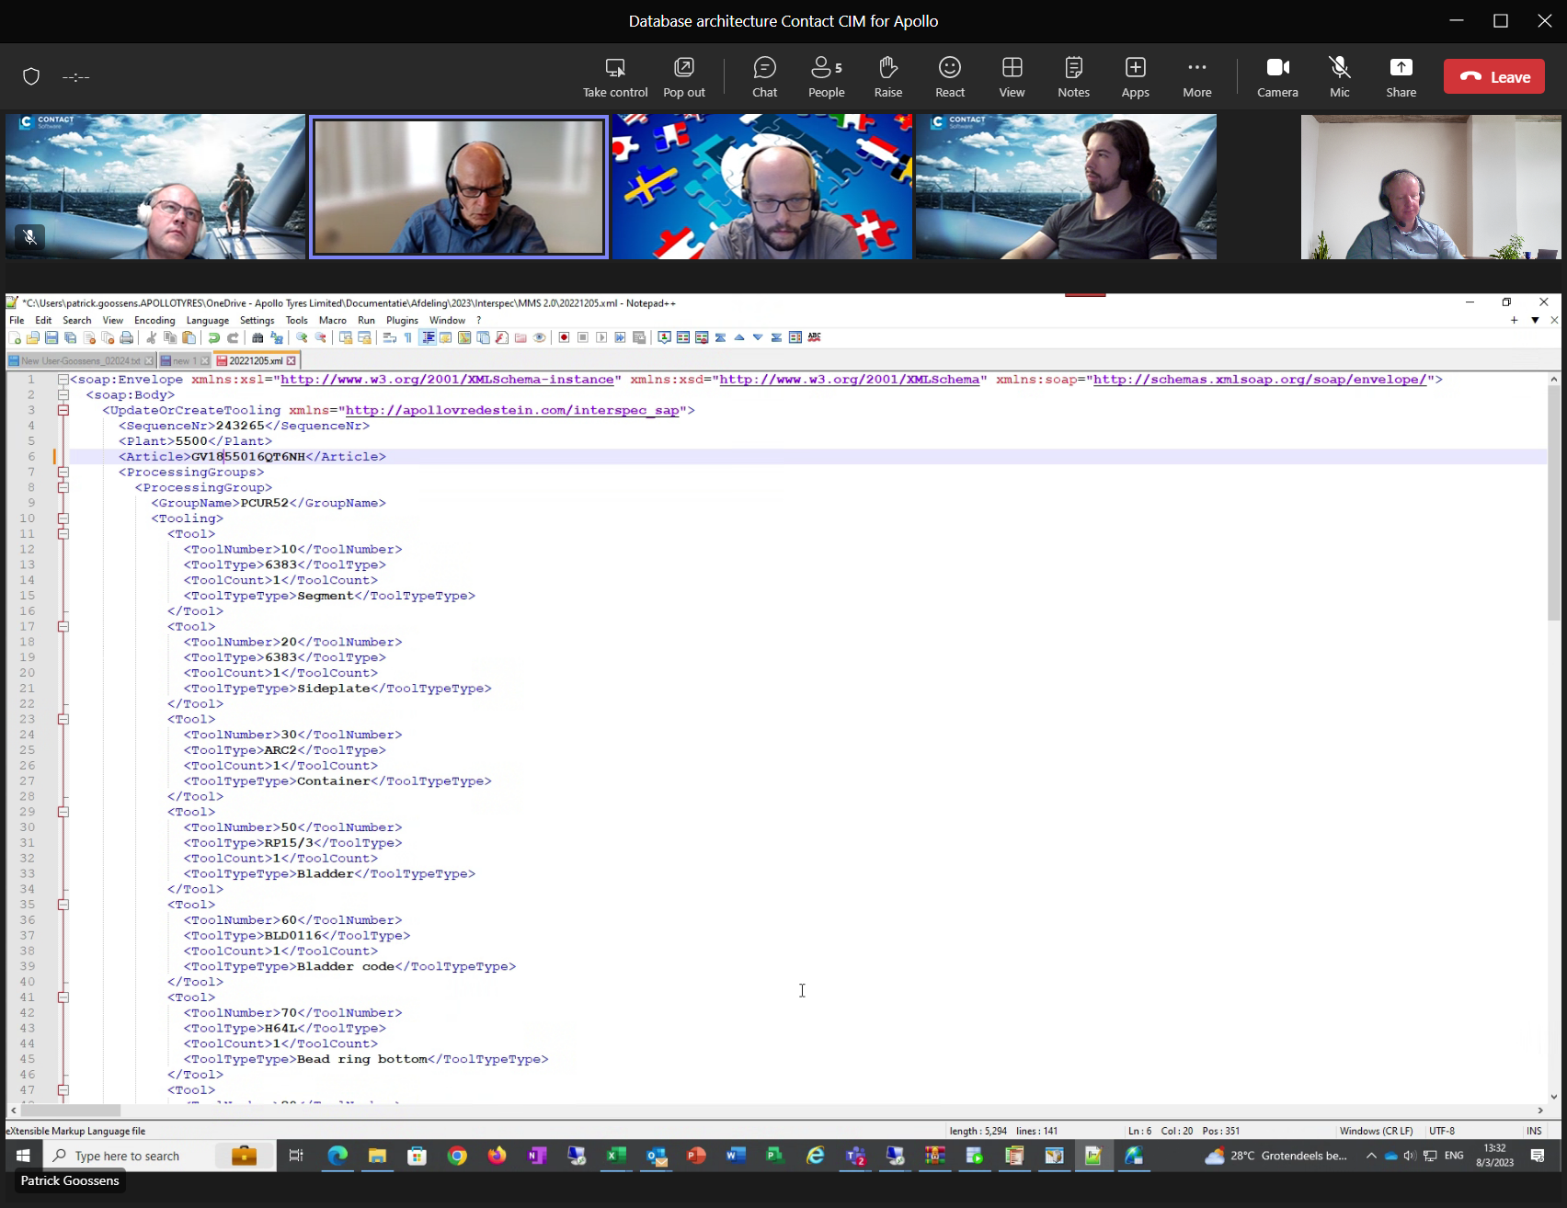

Sap xml Is related to frame and

DISCUSSION: DO WE MIGRATE ALL HISTORIC-DATA TO CONTACT TOO, OR ARE WE GOING TO REPLICATE CONTACT-DATA TO REDSHIFT TOO?

**Current-situation CONTACT:**

-It is an Oracle-database, and qua structure for SPECS almost the same as now in INTERSPEC.

-The database is not ready to let users query from POWER-BI. It is too technical.

-To present the data to Analists/users to create reports with POWER-BI we still need to create a kind of data-access-layer on top of the current-datamodel of CONTACT. CONTACT has the idea to do this by crreating DB-views on top of it.

**Current-situation INTERSPEC/UNILAB:**

-In INTERSPEC a lot of old/historic-data is already truncated, by periodically running delete-jobs in the background. Not for every spec is the related-FRAME-revision available anymore.

-To related historic-data like properties etc. you should actually need the corresponding FRAME before you can interpret the property-values and compare those values with newer/older specifications with the same FRAME-id but with another REVISION.

So what are the advantages and disadvantages of migrating all HISTORIC-data to CONTACT?

Advantages:

-From business-perspective all the available data (historic/current) is in 1x System.

DisAdvantages:

-I would require a lot of resources for this migration of all historic-data. And there is no guarantee that all the data is still-consistent. We don’t know the reason why specifications have been made HISTORIC. This could have been a technical or a functional-reason.

-We are going to use a lot more resources in the NEW-system, for static data that is never going to change again. I would have a negative effect on Performance/Block-Storage/Backup-Storage etc. Storing this data on a READ-only Cloud-environment is far more suitable for that goal.

-Before we are able to present all the available data to an end-user, we still need to create a kind of data-access-layer on top of the current contact-Datamodel. The tables/view in this new data-layer wouldn’t have a relationship with the USER-ROLES/PRIVILEGES as a regular-user in CONTACT-LIMS. If you do nothing then whole authorization-mechanism within GLOBAL-LIMS wouldn’t have any effect.

ADVICE

After the final migration of all the CURRENT-data of INTERSPEC/UNILAB to GLOBAL-LIMS, store only once, all the current/historic data of INTERSPEC/UNILAB in the AWS/REDSHIFT-cloud-environment, in the way we have implemented it already. We only have to do it for all the data-tables, and not only for the ones being used in the current-Athene-reports.

Then, also create a replication mechanism for the GLOBAL-LIMS-data to an AWS/Redshift-enviroment, which keeps running from the start till far in the future.

Build on top of these source-repositories an extra data-access-layer with more functional-views for POWER-BI/PYTHON-reporting/analytics/AI/ML. We can implement a separate PERMISSION-structure for these data-views.

These queries have no impact on resources/performance of the current PRODUCTION-database of GLOBAL-LIMS.